

**NAMA : SHABRINA QOTTRUNNADA**

**KELAS : 1G**

**ABSEN : 24**

**NIM : 2341760160**

**JOBSHEET 13**

**EXPERIMENT 1**

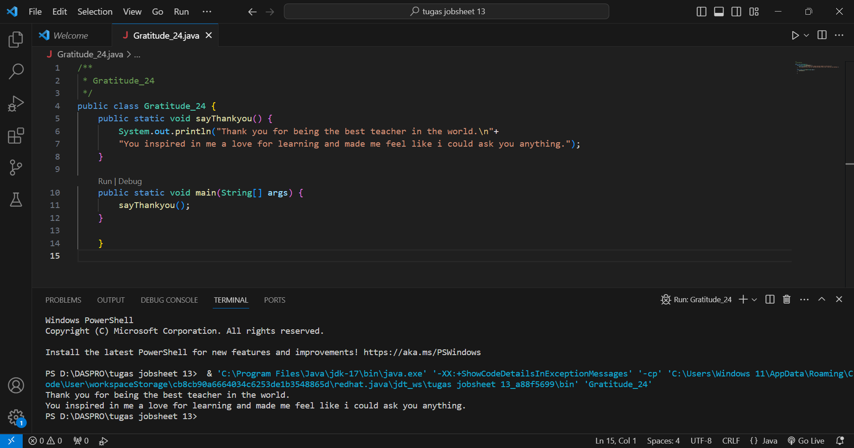

Question!

1. Does function with no parameter always have void datatype?

No, because parameterless functions don't always have the void data type and it depends on the programming language being used. Parameterless functions will be declared with a void return type, while the void data type before that function doesn't return any value.

1. Is it possible for sentence “Thank you for…..dst” to be displayed, without using sayThankyou() function? Modify the program so that it displays the sentence without using function!

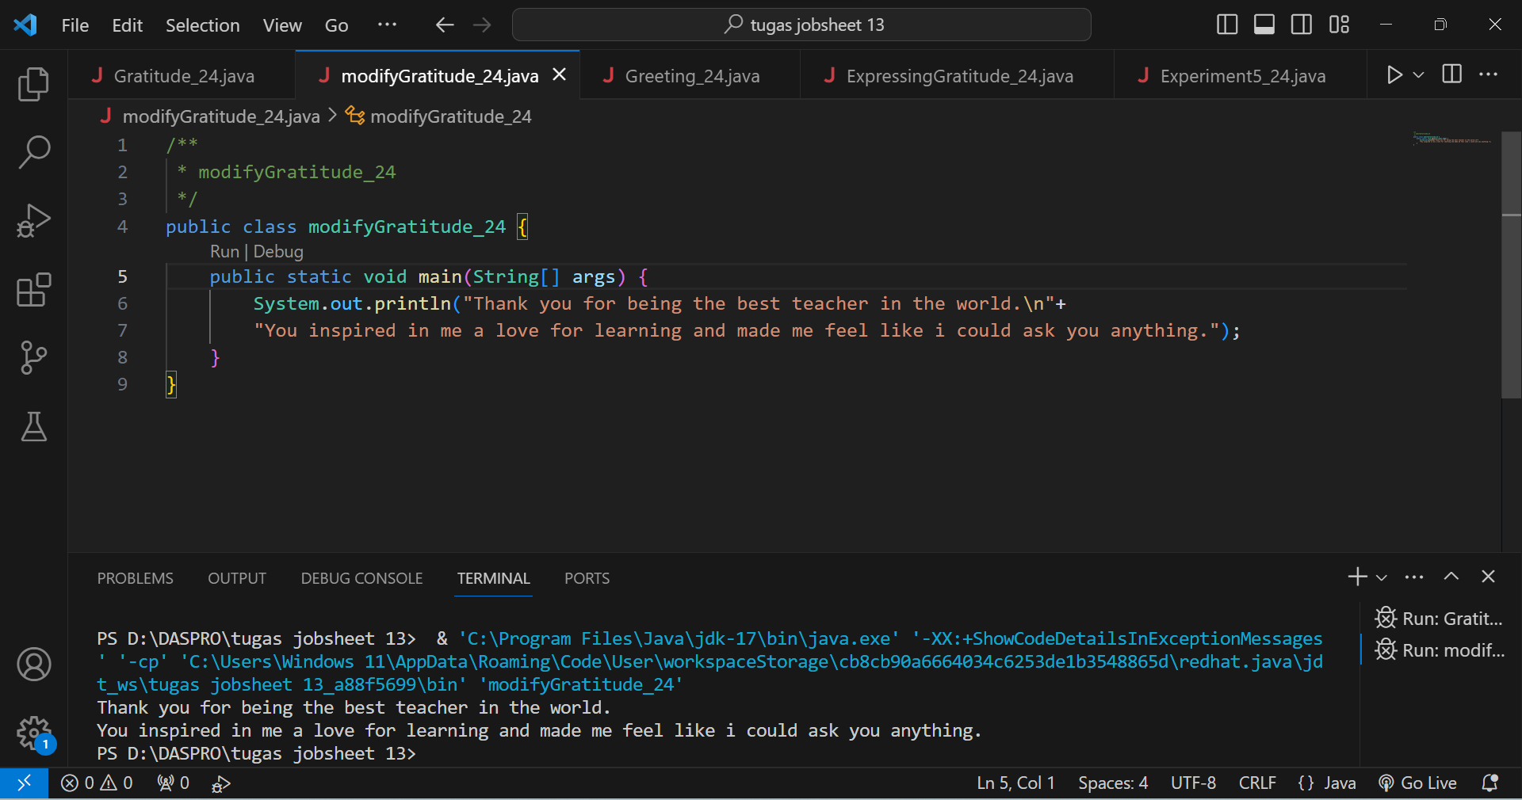

Yes, because after I modify it is very possible and successful if the sentence "Thank you for .....dst" is displayed without using the sayThankyou() function.

1. What are the benefits of using functions in a program?

* modularity, we can break the program into smaller parts, thus making the code more understandable.
* we can write the input code once and later it can be used many times.
* A well-written function can be reused in the next program code, and can even be reused in different files.

**EXPERIMENT 2**

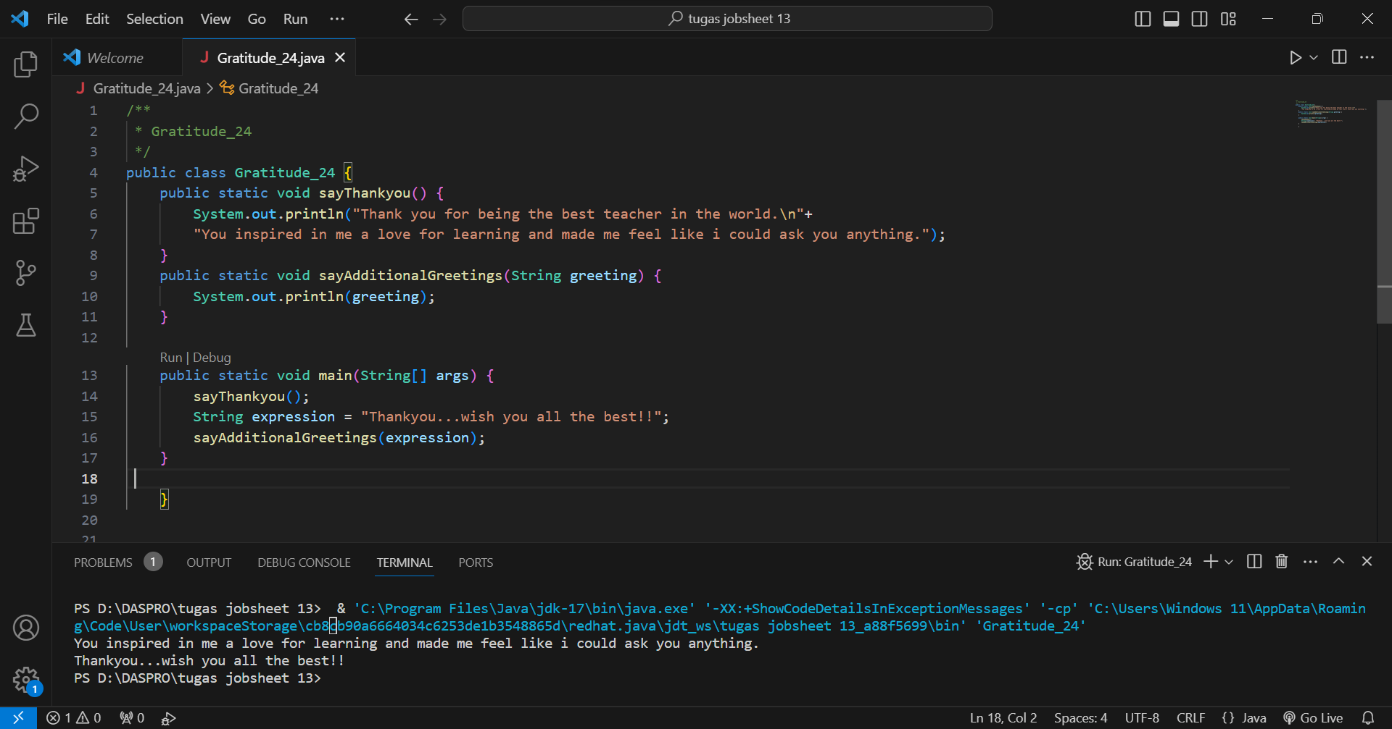

Question!

1. What is the use of a parameter in a function?

* To pass a number or value into a function, and later it will be in the function used to run certain program code only.
* If we use parameters, the function that we create can be structured to accept inputs that have a lot of variations.

1. Is parameter similar to variable? Please explain!

Yes, parameters and variables are two basic elements that are interrelated in programming, but they have different roles. In the case of variables, they have a data type which is a value that can be stored in the program such as int and string. whereas, in the case of parameters, they help to receive a value when the function is called.

1. In the Java programming language, is parameter only used for passing input data? What about output data?

No, parameters in Java programming language are not only used to pass input data, but it can also return the value of its method and that allows the function to provide output data. usually the function specifies the data to output using return.

**EXPERIMENT 3**

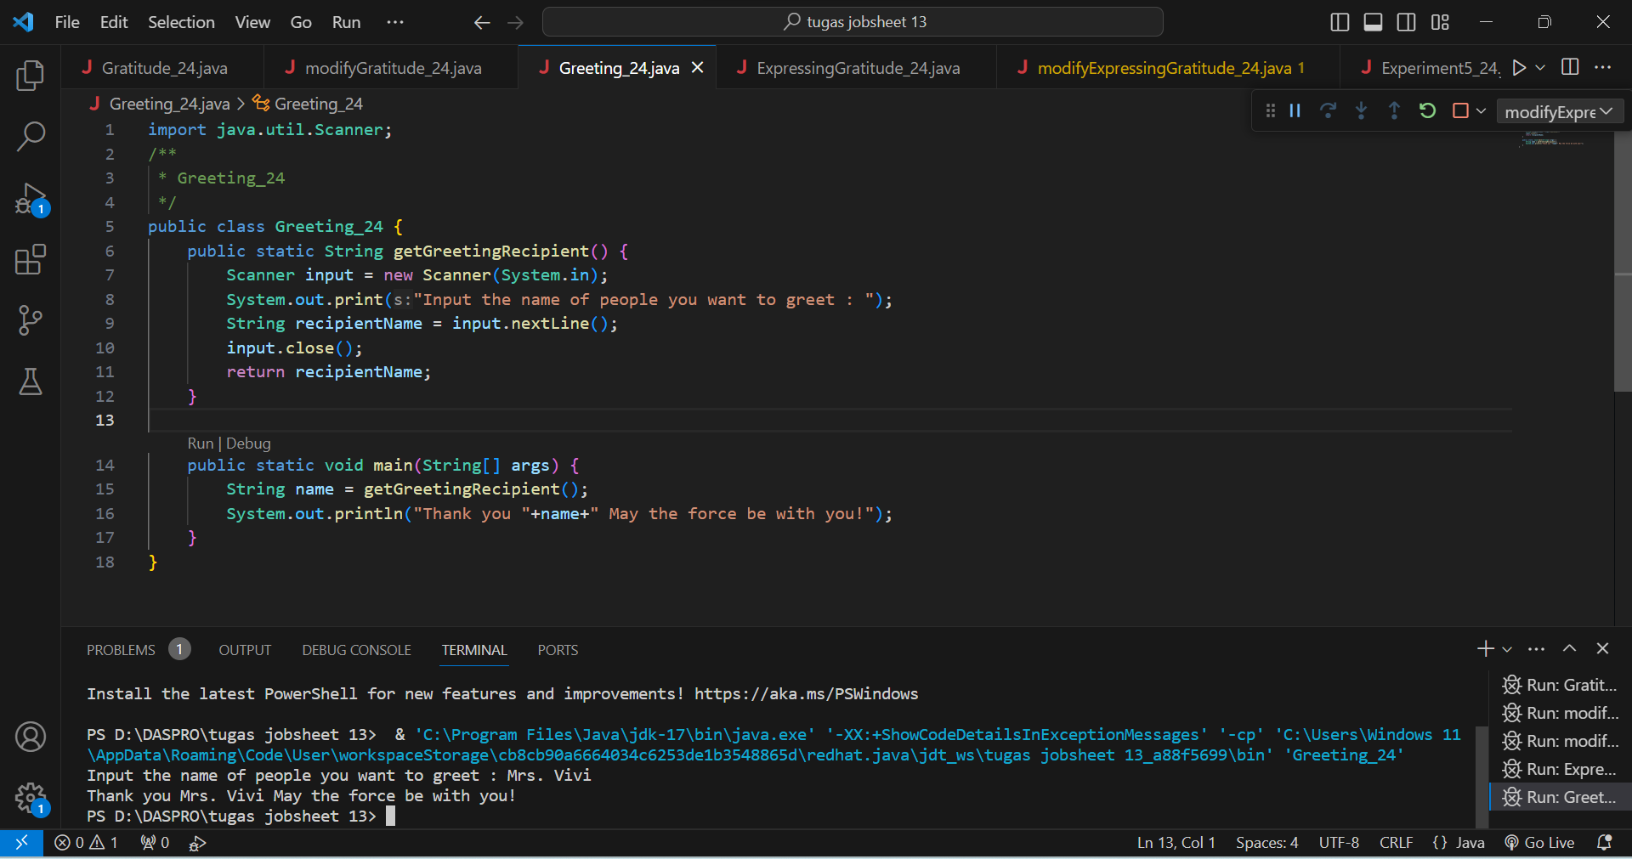

Question!

1. Explain when do we need to create a function that requires a return value?

When we create a function and need a return value is when calculating the value or result, and also when checking the conditions that we have created in the program.

1. Can a System.out.println statement be added inside a function with a return value? What is its impact?

Yes, the System.out.println statement can be added inside a function with a return value. why? because it prints the result of the function if the System.out.println statement is called, and will produce a console output.

1. Can a function without a return value be called inside the main function without being passed to a variable? Like in experiment 1? Explain!

of course it is possible to call a function without a return value inside the main function without passing it to a variable. and then the function can still be executed with its commands even though there is no return value in the variable.

**EXPERIMENT 4**

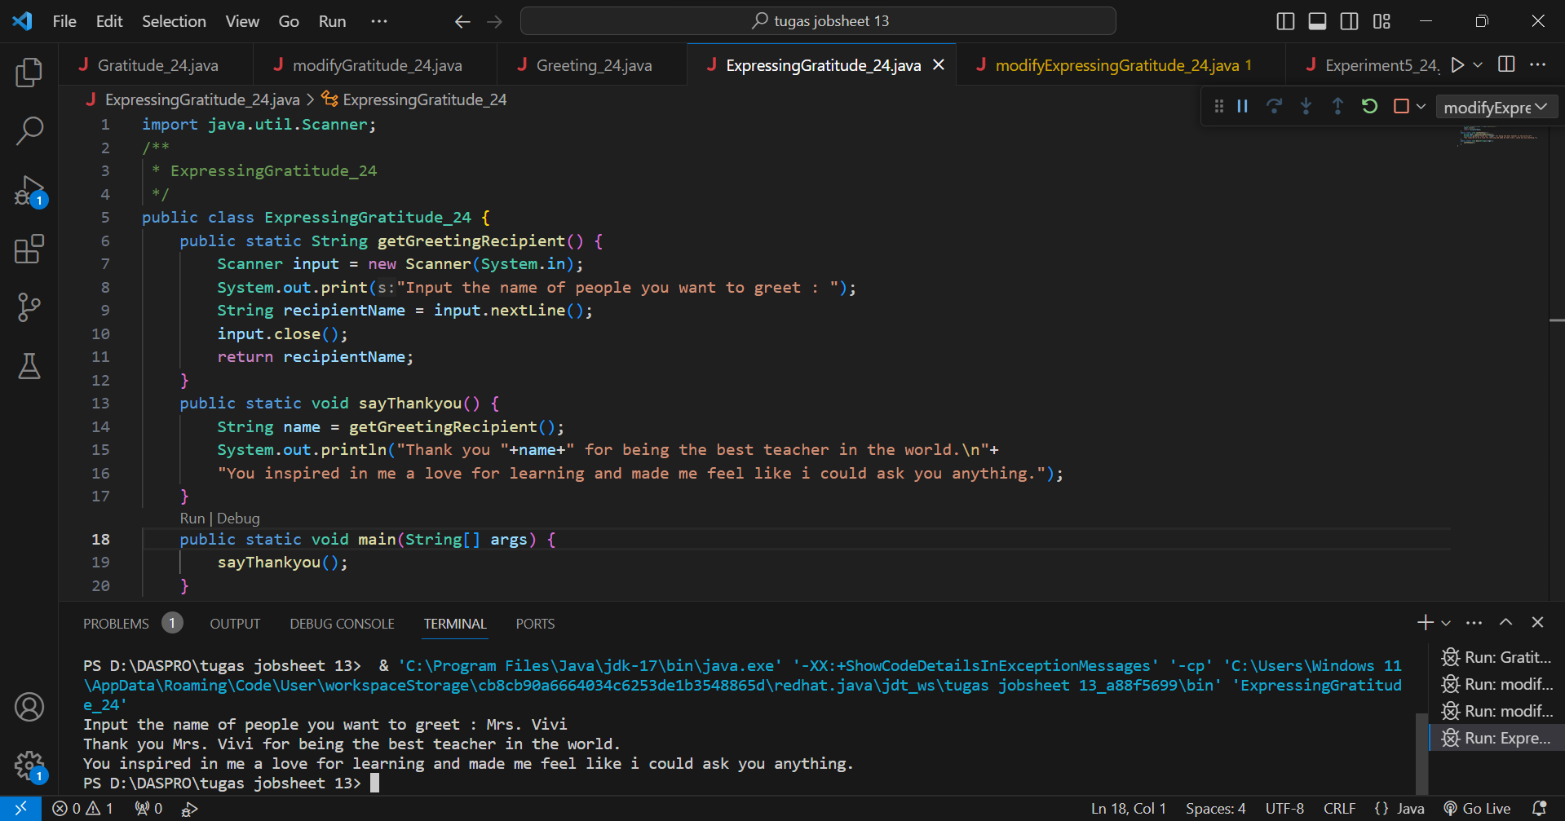

Question!

1. Based on experiment 4, which function will execute first? Please explain!

The first function to be executed in experiment 4 is the getGreetingRecipient() function. if you have provided the name of the recipient of the thank you greeting message in the function, the program will run and print the call along with the recipient's name which will be done by the sayThankyou() function.

1. Which is the correct way to write a function inside a class? Above the main function or below the main function? Please explain!

For writing functions in a class that are at the top of the function or below the function is equally correct, there is no influence and difference for their functionality. However, for general practice, implementing the main function at the bottom of the class to facilitate our code learning.

1. Modify the above program by adding the function sayAdditionalGreetings() with a String input parameter. The sayAdditionalGreetings() function contains additional remarks or greetings that you want to convey to the greeting recipient.

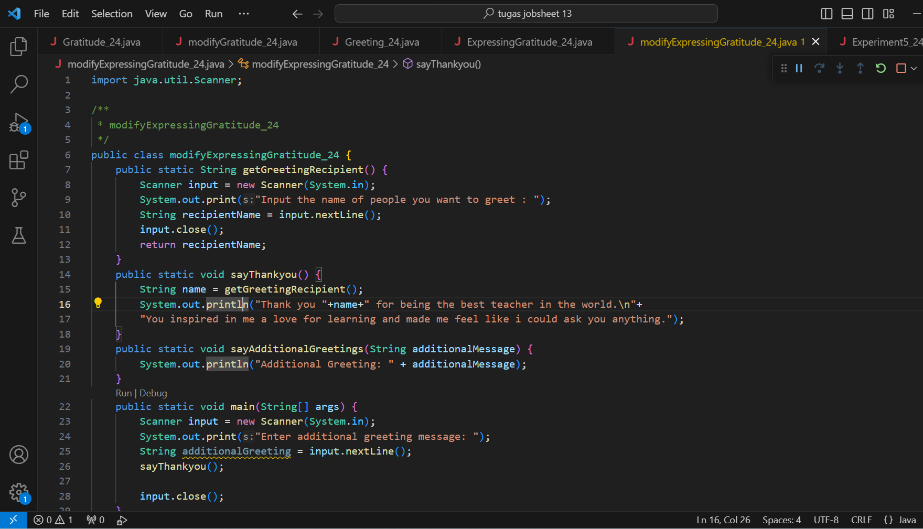

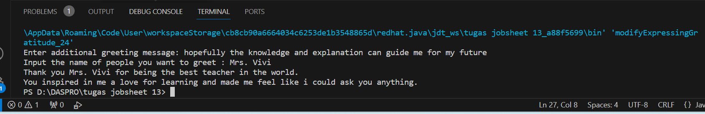

**EXPERIMENT 5**

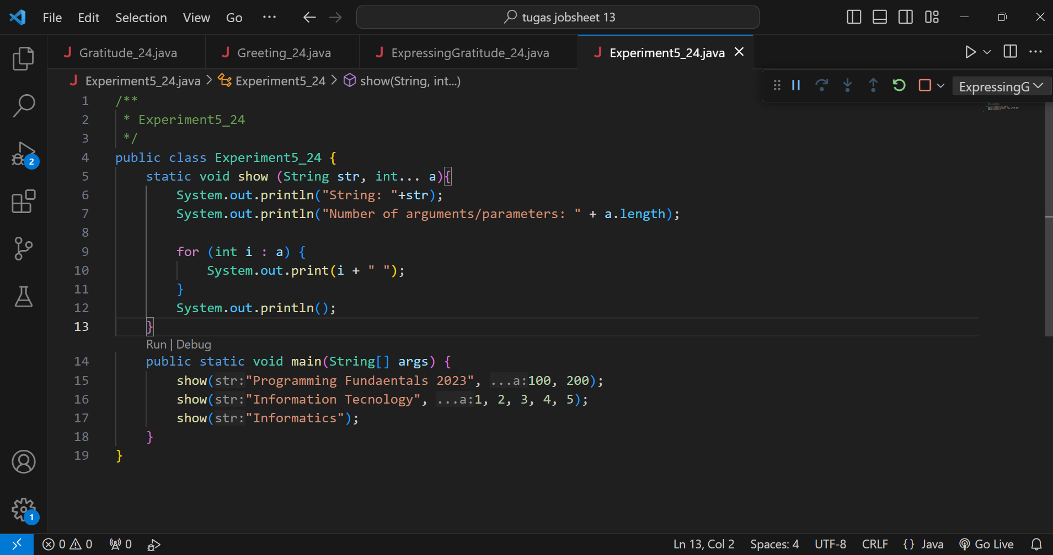

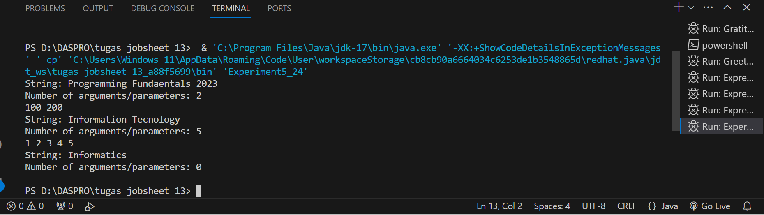

Question!

1. Explain why the parameter in experiment 5 is written as int... a!

The parameter in experiment 5 is written as int... a because it defines a varargs (variable length argument list) in the java code. for the show function, the parameter is used to accept arguments of integer type that can take a variable number of binary (integer) variables when the function is executed.

1. Mention the example of varargs in implementing code to solve real-world problems! (at least 3)

* Varargs can be used to call functions with a variable number of arguments without having to declare the parameters explicitly and clearly without any ambiguity. This allows the code to adjust and change easily.
* Varargs can also be used to calculate subject averages, later we will enter the subject name and the number obtained, later varargs will determine the average value between the values that have been entered.
* Varargs can understand and accept a function with a number of arguments without declaring it separately. So we can conclude that varargs can improve the readability of program code.

1. Can we use two different data types for varargs in one function? Provide an example!

No, we can't use two different data types for variables in one function in java code, only one data type is supported with varargs. and if we create two different functions, we should also need two different types of varargs.